**Experiment No : 5**

Name : Patil Rajashri Jaywant

**Title : Write a queries for Math function and Date and time function.**

**A.MATH Function :**

**1.abs() :**

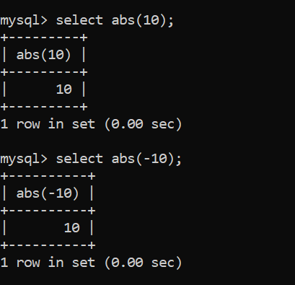

**2.CEIL() :**

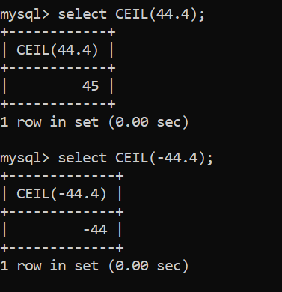

**3.FLOOR() :**

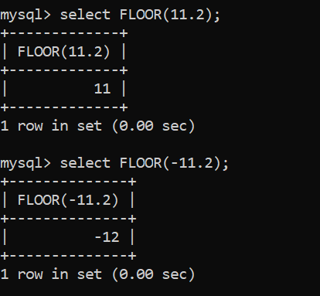

**4.MOD() :**

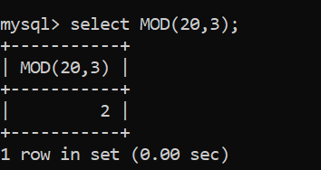

**5.POW() :**

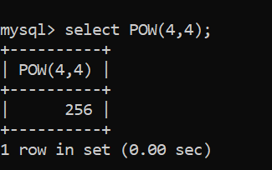

**6.SQRT() :**

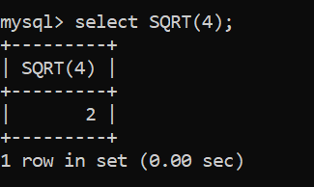

**B. Create database :**

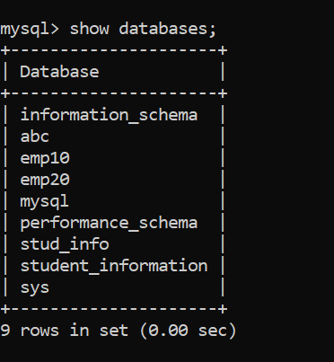





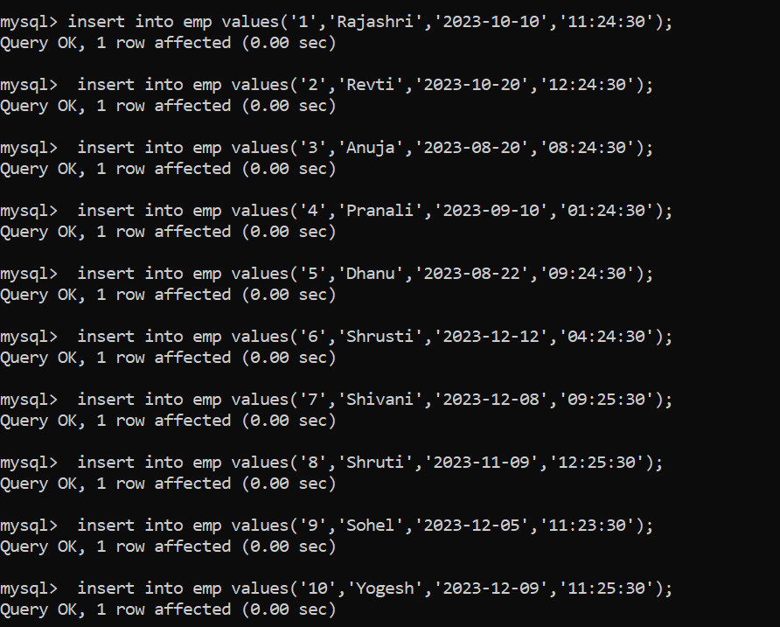

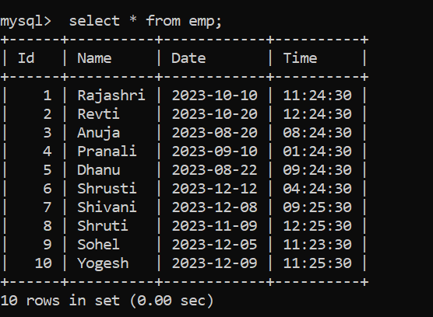

**C. Date And Time Function :**

**1.NOW() :**

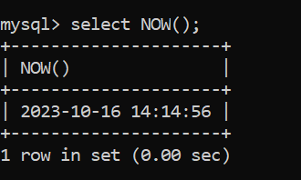

**2.CURDATE() :**

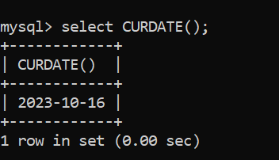

**3.CURTIME :**

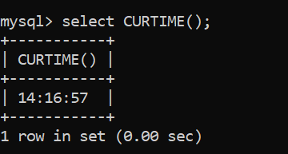

**4.DATE() :**

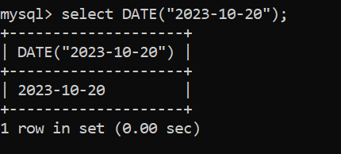

**5.EXTRACT() :**

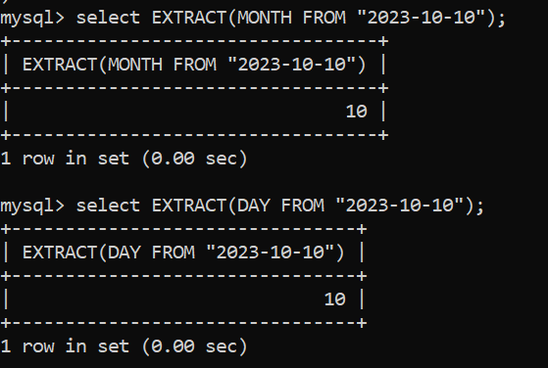

**6.DATE_ADD() and DATE_SUB :**

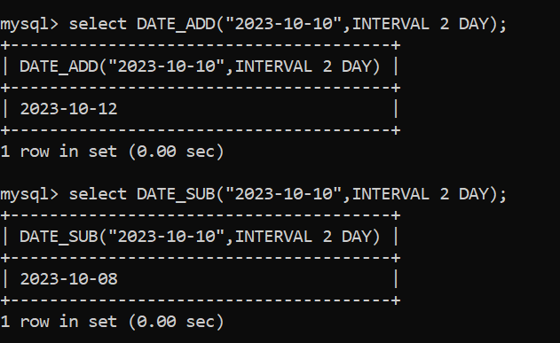

**7.DATEDIFF() :**

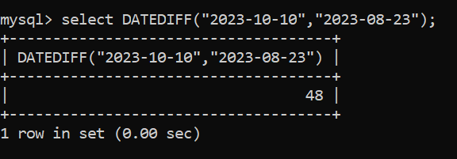

**8.DATE_FORMAT() :**

